**Philosophy**

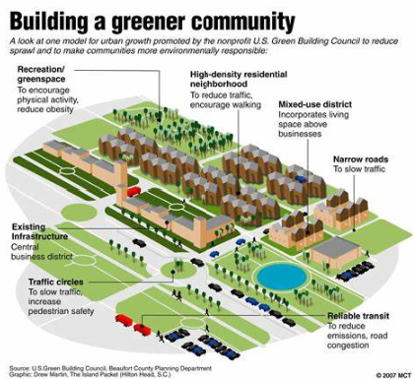

**"The best way to predict the future is to design it."  
— *Buckminster Fuller***

Our future depends on building communities that not only meet today’s needs but also respect and preserve the environment for generations to come. That’s why I am passionate about developing sustainable, eco-friendly housing communities that promote greener living and enhance the well-being of their residents.

By integrating innovative design, renewable materials, and energy-efficient technologies, we can create homes that reduce carbon footprints and minimize environmental impact. Sustainable landscaping, green spaces, and community gardens will encourage a connection with nature, while walkable neighborhoods and easy access to public transportation will help reduce dependence on cars.

These communities will offer more than just a place to live. They will be vibrant, healthy environments that support both people and the planet. By building homes that prioritize sustainability, we can make a meaningful contribution to combating climate change, promoting biodiversity, and fostering a sense of community.

My goal is to redefine how we live and create communities that are financially viable but also environmentally conscious.

**Statement of Purpose**

Throughout my 10-year career in real estate, I have developed a much deeper appreciation for the solutions that ultimately provide shelter for working class families. I have come to understand the crucial need to continue revitalizing the country’s aging housing inventory and developing new housing units to reduce the supply crunch, ultimately making housing more affordable and safer for the future. Growing up in a working-class family, work ethic was instilled in me at a young age by my father and mother who worked as an engineer and high school counselor. The fondest memories I have growing up were working on home improvements with my family from general maintenance to assisting in building a new home in Victoria, Tx. My grandfather built their home from the ground up as well, and it was made clear the value of a safe, well-maintained home to raise a family.

I carried these memories and work ethic with me to The University of Texas at Austin in 2009. During my freshman year, I achieved a 4.0 GPA and immediately was involved in various organizations on campus. I was admitted into the Business Honors Program my sophomore year to pursue a career in business. During my college career, I held internships each summer and worked part time at The Texas State Capitol and at a local gym to put myself through college and explore various career paths. Ultimately, I decided my passion was truly in real estate and obtained an internship at Virtus Real Estate Capital the final summer/fall semester in college. I was hired full time upon graduation in their asset management division, overseeing their student and workforce housing portfolio.

My career in asset management has provided countless opportunities for continuous learning within real estate. Working across the entire life cycle of investments, I’ve had the privilege to work with various parties including developers, civil engineers, GCs, lenders, brokers, investors, and housing authorities. I’ve also had the ability to work across ground-up developments & value-add rehabilitation in both commercial and residential housing. My most recent experience at Amherst Holdings introduced me to the single-family residential sector, where I assisted in rehabbing and providing thousands of rental/ home ownership opportunities to middle income America. This included partnering with architects, builders, our internal design team, construction, supply chain, leasing, and brokerage teams. The last phase of my time with Amherst was spent acquiring land and partnering with surveyors, engineers, and construction on land development for single lot and community development projects. This included traditional stick build product as well as working with our manufacturing plant in Cuero, Tx producing prefabricated modular housing. This experience inspired me to pursue continuing education in land and property development to develop the hard skills necessary to create successful projects that are on time and on budget.

In my search for the right program, it soon became apparent the Master in Land & Property Development Program at Texas A&M was a perfect fit. On a personal note, both of my parents attended Texas A&M and it is fantastic to become a part of the Aggie family and graduate in December 2024. I’m so glad that I decided to attend the program full-time (Academic Year 2023-2024) to leverage the amazing resources the program and university have to offer. I plan to utilize this education and my professional work experience to help solve the critical need for housing our country requires for future growth and sustainability.